***IBM Data Science Capstone Project***

**Recommender System for identification of Amenities in the vicinity of Hi-Tech City in Hyderabad using Four Square Application Programming Interface (API) Data**

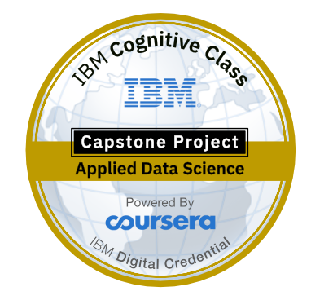

By

**Dr.V.Venkat Ramayya**

**Data Collection:**

The data required for the study is collected in the following sequence.

1. The geospatial data of the HITEC city around Shilparamam is collected using <https://mygeodata.cloud/map/> in the form of *.osm* file (open street map). If the file size exceeds 5MB, the service will be a paid service. An image of the map is shown below.

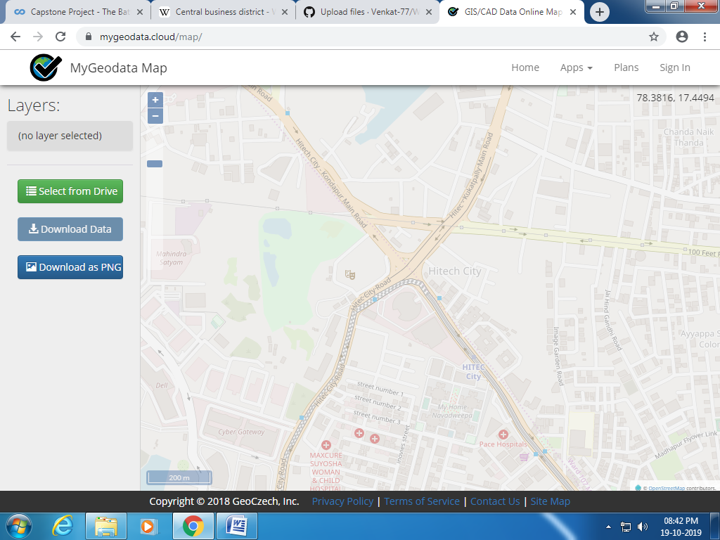

1. In the next step the *.osm* file is converted to geoJson file using <https://mygeodata.cloud/converter/> to get the information about the different types of attributes of the study area. This becomes our starting point for the data analysis. The features that we can collect using the service are addresses, amenity points, amenity polygons, bridges, buildings, land cover, power lines railways, roads etc in the study area.
2. The neighbourhoods in the vicinity of the shilparamam are collected from the geoJSON file and then onwards, and data is manipulated to proceed futher using Foursquare API location data.
3. Cluster Analysis will be used to generate clusters of amenities in the study area.
4. In this project, Foursquare API data was alone used to develop the recommender system.

A sample of geoJSON data is presented below for reference.

